En

EC DECLARATION OF CONFORMITY
Manufacturer | Ningbo Dwafer Electrical Appliances Co.,Ltd.  No.2.Zone,1 Hongxi Industrial Zone, Chunhu,Street, Fenghua Distric, Ningbo,City ,Zhejiang Province  amber@dwafer.cn
Authorised representative | Lienco SAS  8 Rue Marcel Cerdan, 77600, Bussy Saint Georges, France  contact@lienco.eu
Product Name | Spot Cleaner
Product Model Number | DY-516
Item Number
Picture | 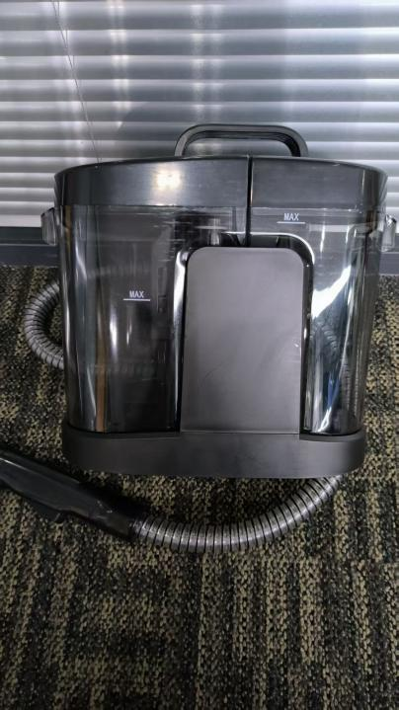

We declare under our sole responsibility that the above referenced product complies with the following relevant EU Union harmonization legislations,applicable in part or in whole.

Directives Applied | Standards Applied | Report No
EMC Directive (2014/30/EU) | EN IEC 55014-1:2021  EN IEC 55014-2:2021  EN IEC 61000-3-2: 2019+A1:2021+A2:2024  EN 61000-3-3: 2013+A1: 2019+A2: 2021 | EFSH25080378-IE-02-E01
LVD Directive (2014/35/EU) | IEC 60335-2-2:2019, with IEC 60335-1:2010, COR1:2010COR2:2010, AMD1:2013, COR1:2014, AMD2:2016, COR1:2016EN IEC 60335-2-2:2023 + A11:2023EN 60335-1:2012 + A11:2014 + A13:2017+ A1:2019A14:2019 + A2:2019+ A15:2021 + A16:2023EN 62233:2008 | EFSH25080378-IE-01-L01
ROHS (2011/65/EU) | Total concentration of Lead, Cadmium, Mercury, Chromium VI,Polybrominated Biphenyls (PBBs), Polybrominated Diphenyl Ethers(PBDEs), Bis (2-ethylhexyl) phthalate (DEHP), Butyl benzyl phthalate(BBP), Dibutyl phthalate (DBP) and Diisobutyl phthalate (DIBP) inaccordance with EC Directive 2011/65/EU and its amendmentDirective (EU) 2015/863 (RoHS) | EFHZ26011315-CG-01
REACH | According to European Commission  Regulation 1907/2006 (REACH Act), to testthe SVHC content which have been listed inECHA's SVHC candidate list till  Nov.05.2025 | EFHZ26011315-CG-02
This product was CE marked in ：2026 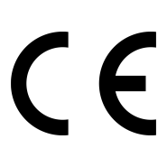

I represent and warrant that: (i) I am a legal representative of Ningbo Dwafer Electrical Appliances Co.,Ltd.; (ii) Ningbo Dwafer Electrical Appliances Co.,Ltd. is responsible for the compliance of the product in the EU; and (iii) the information provided in this Declaration of Conformity in support of the safety and effectiveness of the product is true and accurate and does not contain any material omissions.
Signed for and on behalf of: | Ningbo Dwafer Electrical Appliances Co.,Ltd.
Name: | Xue Shengli
Job Title: | Manager
Place and date of issue： | 2026-8-6

